**Product Management Core Concepts**

**Environment Analysis (PESTLE)**

P – Political factors

E – Environmental factors

S – Social Factors

T – Technological Factors

L – Legal factors

E – Environmental Factors

**Industry analysis – Porters 5 forces model**

Let's quickly recap our learnings from the videos.

 Porter's model talks of five forces that act on an industry:

1. Threat of new entrants

2. Buyer power

3. Supplier power

4. Threat of substitutes

5. Competitive rivalry

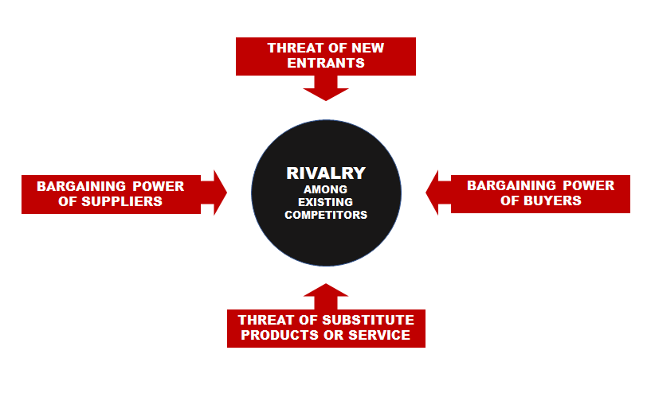

Porter's 5 Forces Model for Industry Analysis

Use the model for evaluating your industry.

*Is it too crowded?*

*Are there too many regulations?*

*Would your future customers have complete control of your profitability?*

*Would your customers end up dictating your business decisions?*

*Can a new entrant quickly gain market share and render your business obsolete?*

*Can a completely different industry render the industry obsolete?*